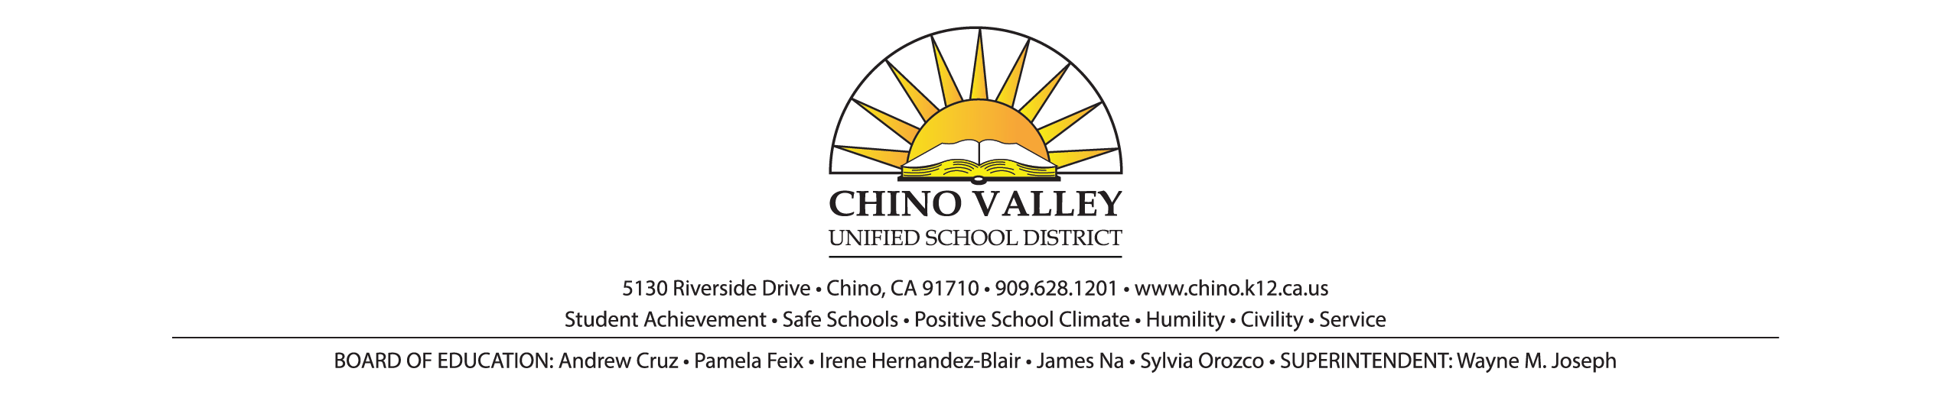**PRESS RELEASE**

**FOR IMMEDIATE RELEASE** **CONTACT**: Imee Perius, Director of Communications

January 25, 2018 (909) 628-1201 ext. 1616, *OR*

Brenda Dunkle, Multi Media Communications Specialist

(909) 628-1201 ext. 1617

**38th Annual Student Government Day Provides Chino Valley Unified School District Seniors Opportunity for First Hand Experience of Local Government**

***Students will fill roles of elected officials and government leaders***

CHINO— More than 100 Chino Valley Unified School District (CVUSD) High school seniors from Ayala, Chino, Chino Hills, Don Lugo, Buena Vista Continuation and Boys Republic high schools will participate in a mock CVUSD Board of Education meeting, Chino City Council meeting and Chino Hills City Council meeting as well as become school principals for the morning during the 38th annual **Student Government Day on Thursday, February 15, 2018.** The day’s events will begin at 8:00 a.m.

Each participating student is paired with an elected official or government agency leader to learn about the position and role they will be undertaking. A “Student Principal for a Day” will go to the school to learn about school administration and to shadow the principal.

“Now in its 38th year, Student Government Day is an event that our students and community leaders have come to look forward to and rely on as part of the Chino Valley Unified School District learning experience,” said Superintendent of Schools Wayne Joseph. “and what better way is there to shepherd and inspire our future leaders than to give them an up close and interactive look at how local government and school districts work.”

Student Government Day morning meetings and events will conclude at 11:45 a.m., followed by a luncheon at Chino Hills High School.

*Media Instructions: Please RSVP to arrange your observation at any of the following or if you would like to join us for lunch with the students and agency participants.*

###